## Chapter 4.2 One Pass Algorithm

***Question:***

How could we execute each single operation of Logical Query Plan? (i.e. Join or Selection) Selecting an operator algorithm is a necessary part to convert Logical Query Plan to Physical Query Plan.

***Classification based on Algorithm:***

1. *Method based on Sort.*
2. *Method based on Hash.*
3. *Method based on Index.*

***Classification based on Difficulty and Cost:***

1. *One – Pass Algorithm:*

Reading data from disk for one time. This method requires that at least one Operation Object of the Operation can be stored into the main memory. (Especially for Projection and Selection)

1. *Two – Pass Algorithm:*

Data Size is too big to be put into the available main memory, but it is not the biggest data set. The feature of two – pass algorithm is to read data from disk and deal with them in one method and re-write them back to the disk, then in next pass, read the data again.

1. *Three – Pass (Multi – Pass) Algorithm:*

The Three – Pass (Multi - Pass) Algorithm has no limitation for the data size. They can finish work in three or multi - pass algorithm. They are also extension of Recursive Algorithm.

***Classification for Operator:***

1. *One Single Tuple, Unitary Operation:*

The Operation *(Selection and Projection Operator)* does not need to store the whole Relation or even the most part of the Relation into the main memory. The Operation reads one Block for one time, and generate the output by using the main memory.

1. *Whole Relation, Unitary Operation:*

The Operation *(Grouping and Deduplication Operator)* does need the whole or main part of tuples, then One – Pass Algorithm is limited to M size *(The buffer number that can be used in main memory.)* or smaller Relation.

1. *Whole Relation, Dual Operation:*

*(Union[并集], Intersection[交集], Difference[差集], Joint[连接], Product[积集] and Packet[包集])* If we want to use One – Pass Algorithm, then the size of Operator is limited to M size.

### Chapter 4.2.1 One Pass Algorithm for Single Tuple Operation

***Principle:***

No matter whether Relation R can be stored into main memory, Operations *(Selection and Projection)* have their obvious algorithms.

***Process:***

* Read one block of Relation R into the input buffer, operates on each tuple, and move the selected/projected tuple into the output buffer.

*(The output buffer maybe another operation input buffer, so the output buffer doesn’t count to the whole buffer.)*

* No matter how big the block B is, it requires that it must satisfies M >= 1.



***Cost:***

* The cost of operations *(Selection and Projection)* is decided by how Operation Objects in Relation R are provided. If Relation R is on the disk, then the cost is once execution of Table – Scan or Index – Scan.
* Normally, if Relation R is cluster, then the cost is *B(R)*; Otherwise, if Relation R is non – cluster, then cost is *T(R)*.

### Chapter 4.2.2 One Pass Algorithm for Single Tuple Operation in the Whole Relation

Let’s consider One – Pass Algorithm for Single Tuple in whole Relation: *Deduplication and Grouping*.

***Deduplication:***

1. *Prerequisite:*
2. If the first time visiting the tuple, just duplicate it to the output buffer and output it.
3. If we had visited the tuple before, then no need to output it.

*(In order to support two prerequisites, then keep one copy for each tuple in main memory. Using one memory buffer to keep one block of one tuple of Relation while other M - 1 buffer area can be used to save every tuple that we saw before so far.)*

1. *Process:*

* Take the data structure into consideration when we store the visited tuple. We compare a new tuple in Relation R with tuples that have been visited before.
* If the current tuple doesn’t equal to any in the tuple collection, then we need to copy it into output buffer and add it to the visited tuple collection.

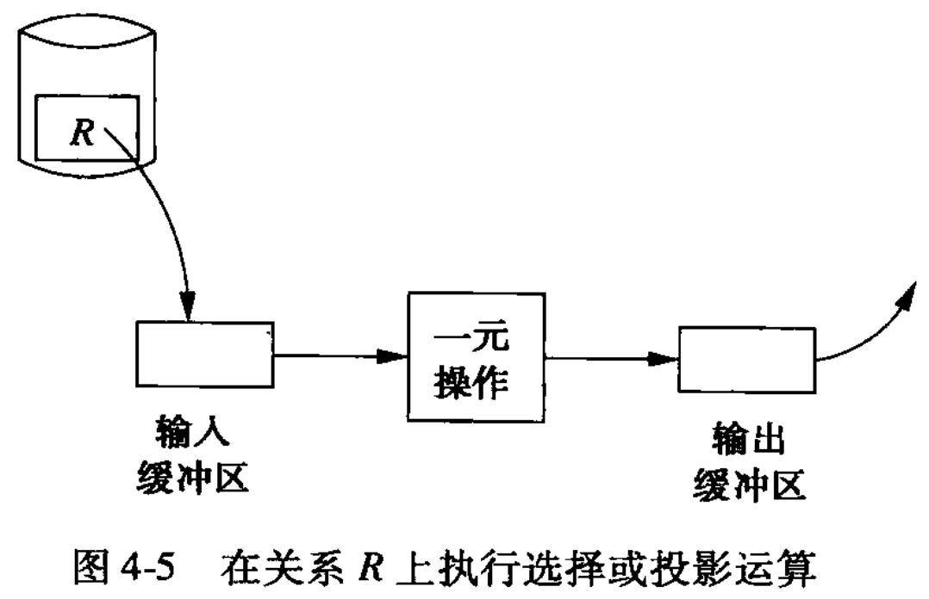

1. *Cost:*

Store the same number tuples into M - 1 buffer memory as M - 1 blocks of Relation R. We hope that every different tuple of Relation R can be stored into the main memory, then *B(Deduplication(R)) <= M - 1*. In the same time, *M > 1*, so *B(Deduplication(R)) <= M.*

*Attention:*

*Deduplication(R)* can not be evaluated in the Relation R. If we underrate it’s value, while *B(Deduplication(R))* is much bigger than M, then we need pay large cost for it, since the tuples in Relation R need to go back and forth into main memory.

***Grouping:***

1. *Definition:*
2. Grouping Operation gives us zero or multiple grouping attributes or possibly one or multiple cluster attributes.
3. Create an attribute for one group in main memory, then scan tuples in Relation R one block for one time.
4. The attribute of each group includes group value and one or multiple aggregated property value.
5. *Classification:*
6. *MIN(a)* or *MAX(a)* aggregation, *MIN(a)* is used to record the minimum value in property a of all tuples so far. While *MAX(a)* is used to record the maximum value in property a of all tuples so far. When visits one tuple in the group, if possible, then change the minimum or maximum value.
7. Any *COUNT* aggregation, if one tuple exists, then add 1 to COUNT value.
8. *SUM(a)* aggregation, if a does not equal to NULL, then add the value of property a to *SUM(a)* when scan the group so far.
9. *AVG(a)*. Two accumulated values are needed to keep. One is the number of tuples among the group and *SUM(a)* on the property a. After scanning, calculate *AVG(a)* equals to *SUM(a)* divided by *COUNT*.

*(When all tuples of Relation R have been read into input buffer memory, and have been used to calculate for each Group Aggregation, then generates one tuple output for each group.)*

*Attention:*

Not until we finish scan all tuples, then we create output. So this algorithm doesn’t fit for the iterator structure. Before using GetNext can get the next tuple, method Open must be used to do the grouping.

*Supplement:*

One main memory data structure is needed to help us find each Group attribute of known property value. Hash data structure and balanced binary tree can be effective.

*(The Key of Query can only be Grouping Attribute.)*

1. *Cost:*
2. One Pass algorithm requires B(R) disk I/O, which is same as the One Pass of any Unitary Operation. Although M is less than B.
3. The attribute of Group is not longer than the tuple of Group, and the number of Group is less than the number of tuples.

### Chapter 4.2.3 One Pass Algorithm for Two Tuples Operation